WEEK 5: Microservices with Spring Boot 3 and Spring Cloud
Exercise 1: Creating Microservices for account and loan
For account
package com.cognizant.account.controller;
import org.springframework.web.bind.annotation.*;
import java.util.Map;

@RestController
@RequestMapping("/accounts")
public class AccountController {

@GetMapping("/{number}")
public Map<String, Object> getAccount(@PathVariable String number) {
return Map.of(
"number", number,
"type", "savings",
"balance", 234343
);
}

@GetMapping
public String checkStatus() {
return "Account Service is UP";
}
}

package com.cognizant.account;

import org.springframework.boot.SpringApplication;
import org.springframework.boot.autoconfigure.SpringBootApplication;
import org.springframework.cloud.client.discovery.EnableDiscoveryClient;

@SpringBootApplication
@EnableDiscoveryClient
public class AccountApplication {
public static void main(String[] args) {
SpringApplication.run(AccountApplication.class, args);
}
}

server.port=8080
spring.application.name=ACCOUNT
eureka.client.service-url.defaultZone=http://localhost:8761/eureka

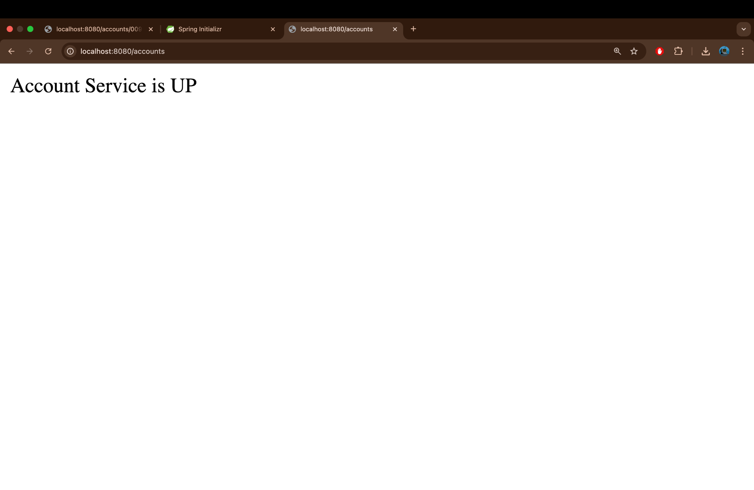

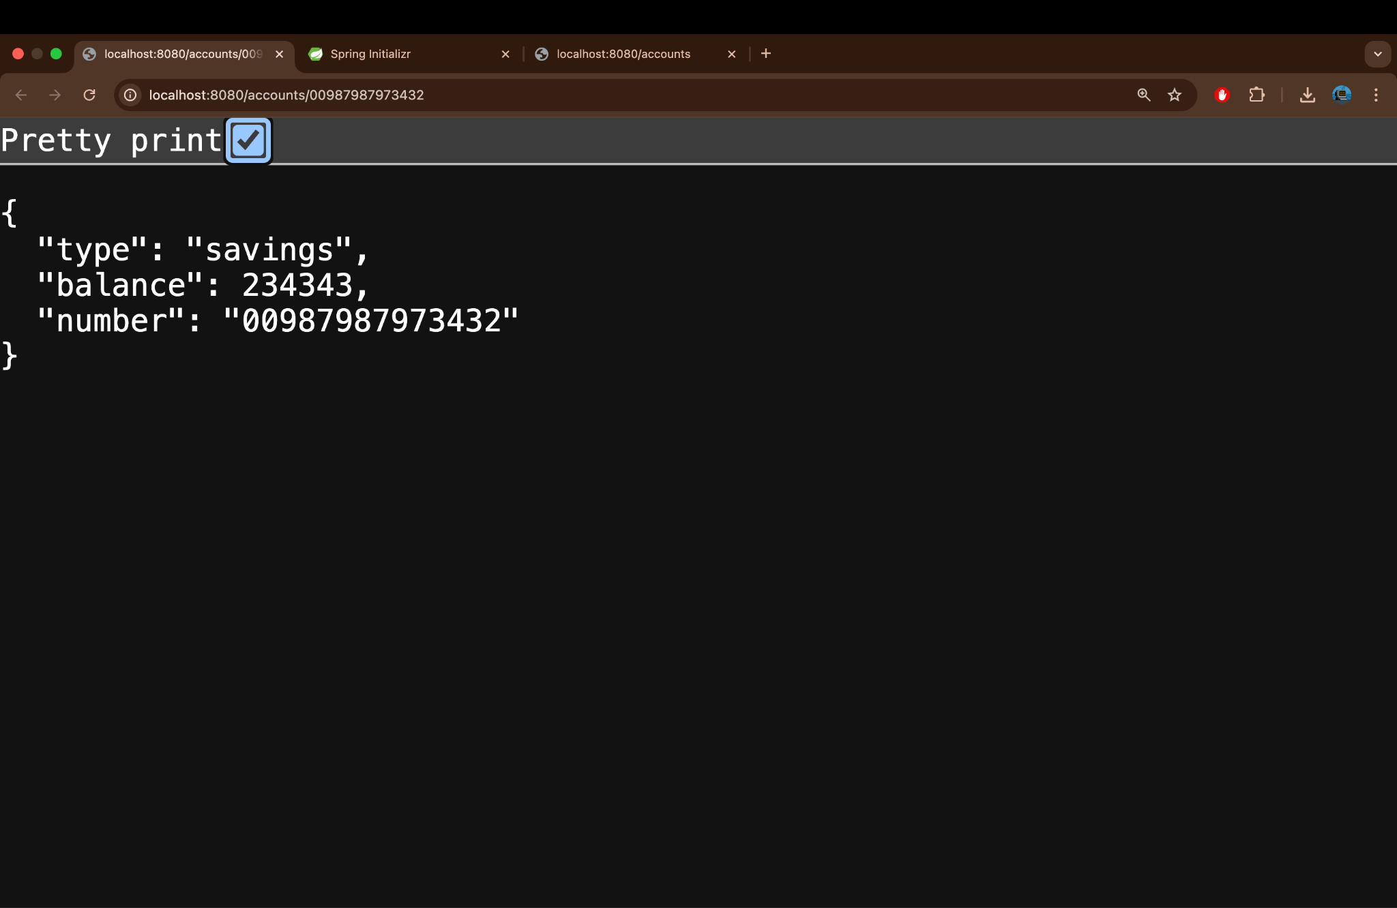

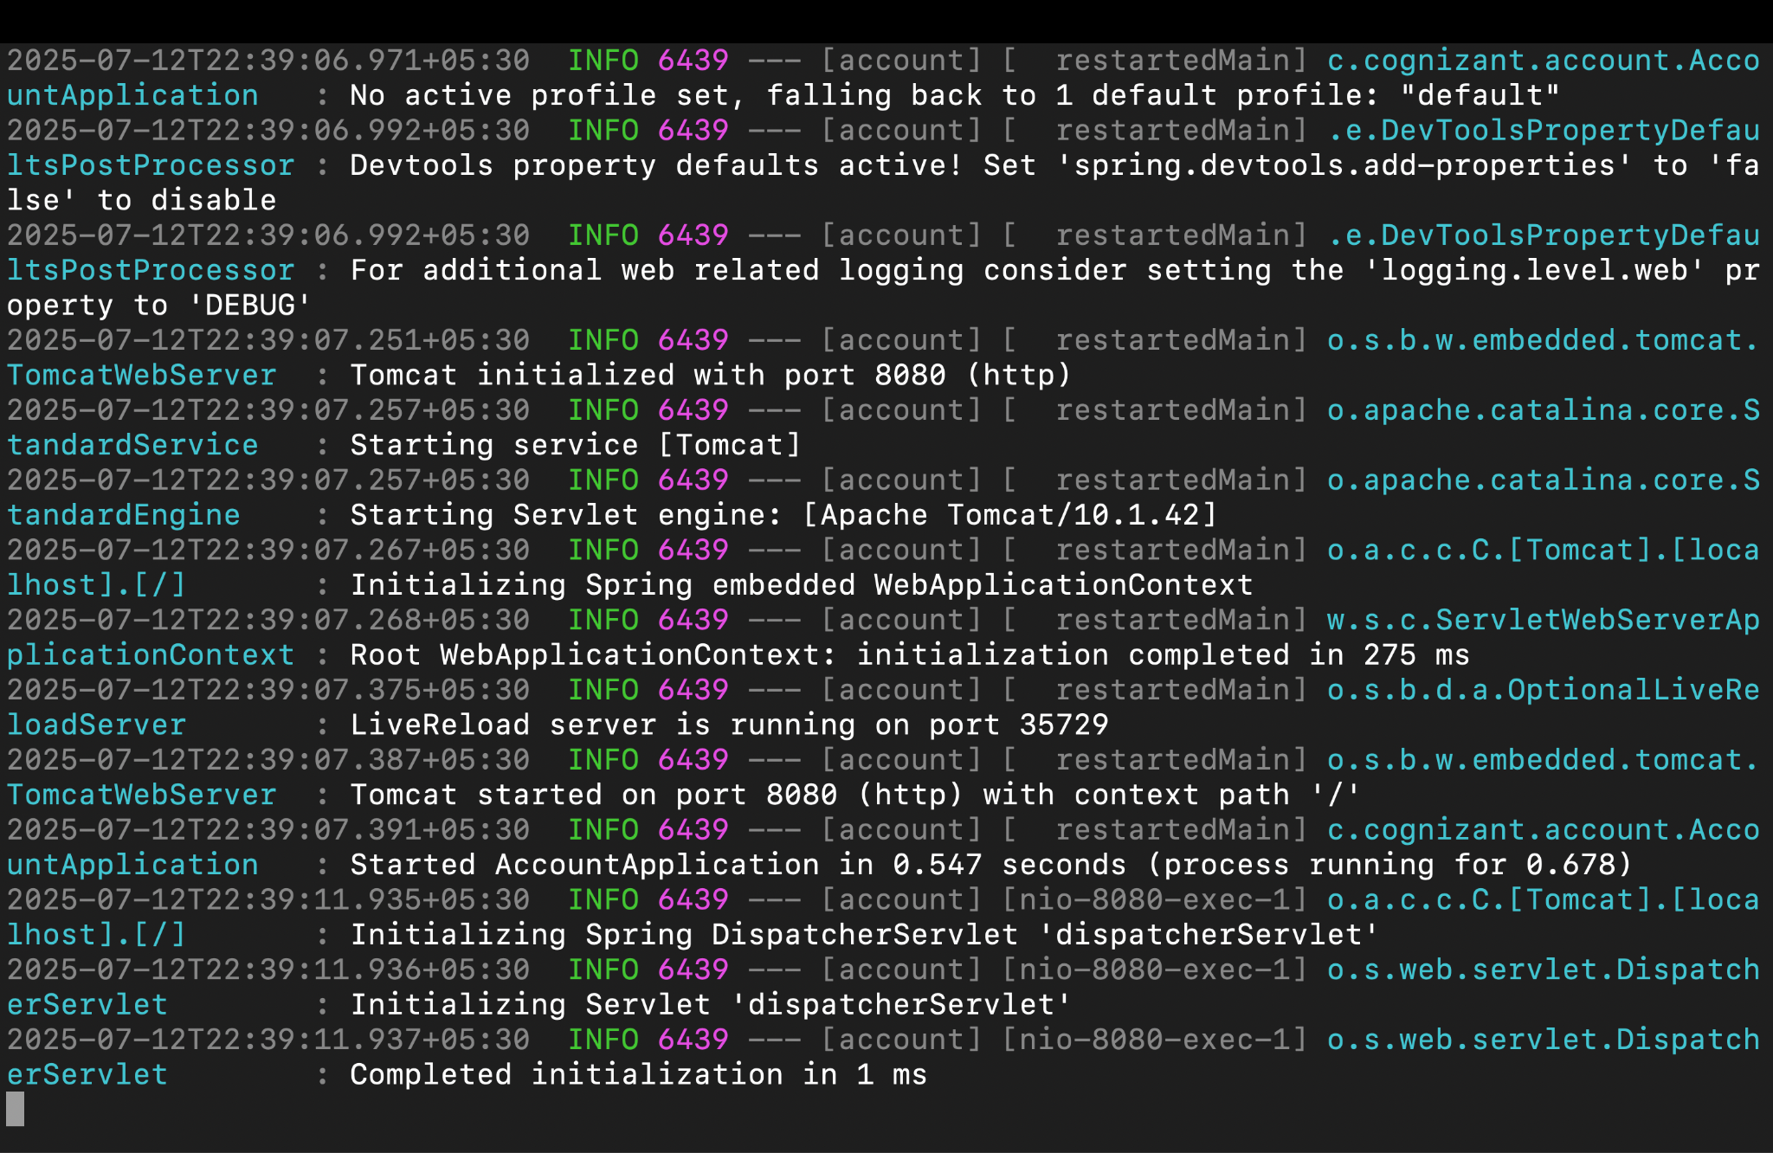

For Loan
package com.cognizant.loan.controller;

import org.springframework.web.bind.annotation.*;
import java.util.Map;

@RestController
@RequestMapping("/loans")
public class LoanController {

@GetMapping("/{number}")
public Map<String, Object> getLoan(@PathVariable String number) {
return Map.of(
"number", number,
"type", "home loan",
"amount", 1000000
);
}

@GetMapping
public String checkStatus() {
return "Loan Service is UP";
}
}
package com.cognizant.loan;

import org.springframework.boot.SpringApplication;
import org.springframework.boot.autoconfigure.SpringBootApplication;
import org.springframework.cloud.client.discovery.EnableDiscoveryClient;

@SpringBootApplication
@EnableDiscoveryClient
public class LoanApplication {
public static void main(String[] args) {
SpringApplication.run(LoanApplication.class, args);
}
}

server.port=8081
spring.application.name=LOAN
eureka.client.service-url.defaultZone=http://localhost:8761/eureka

Output:

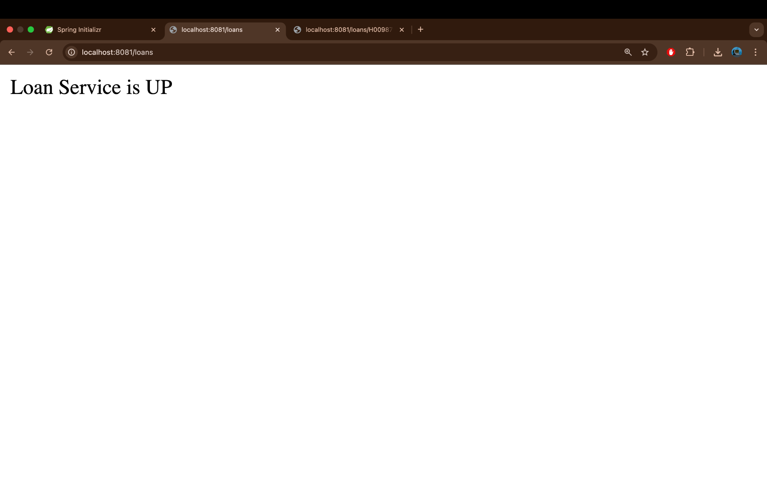
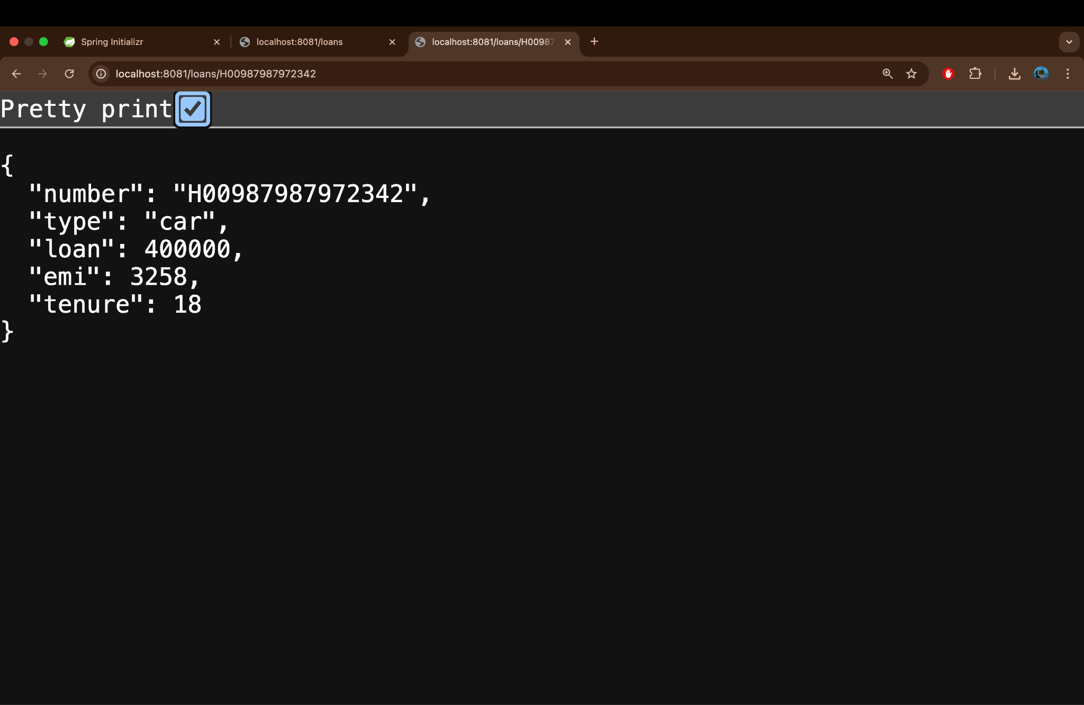
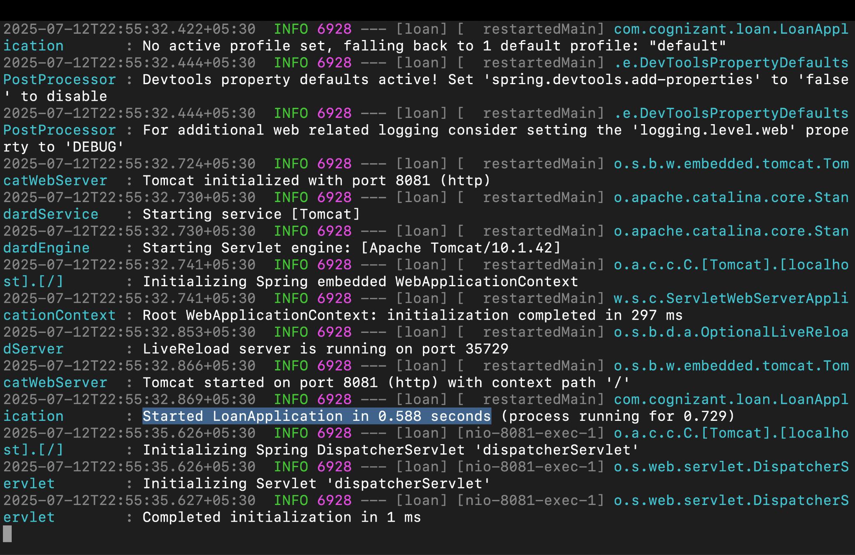

EXERCISE 2:Create Eureka Discovery Server and register microservices
package com.cognizant.discovery;

import org.springframework.boot.SpringApplication;
import org.springframework.boot.autoconfigure.SpringBootApplication;
import org.springframework.cloud.netflix.eureka.server.EnableEurekaServer;

@SpringBootApplication
@EnableEurekaServer
public class EurekaDiscoveryServerApplication {
public static void main(String[] args) {
SpringApplication.run(EurekaDiscoveryServerApplication.class, args);
}
}
server.port=8761
eureka.client.register-with-eureka=false
eureka.client.fetch-registry=false
Output:

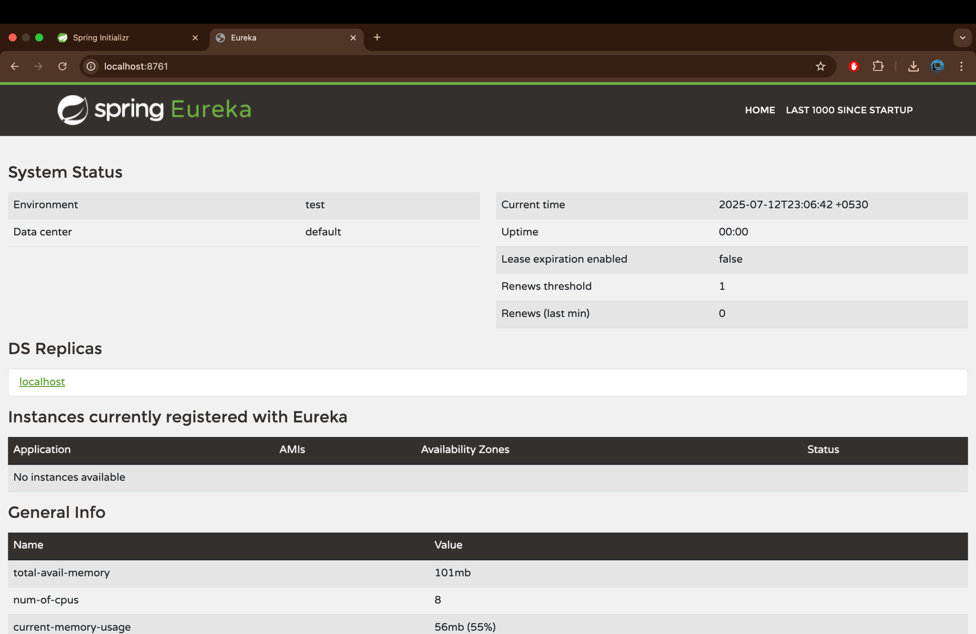

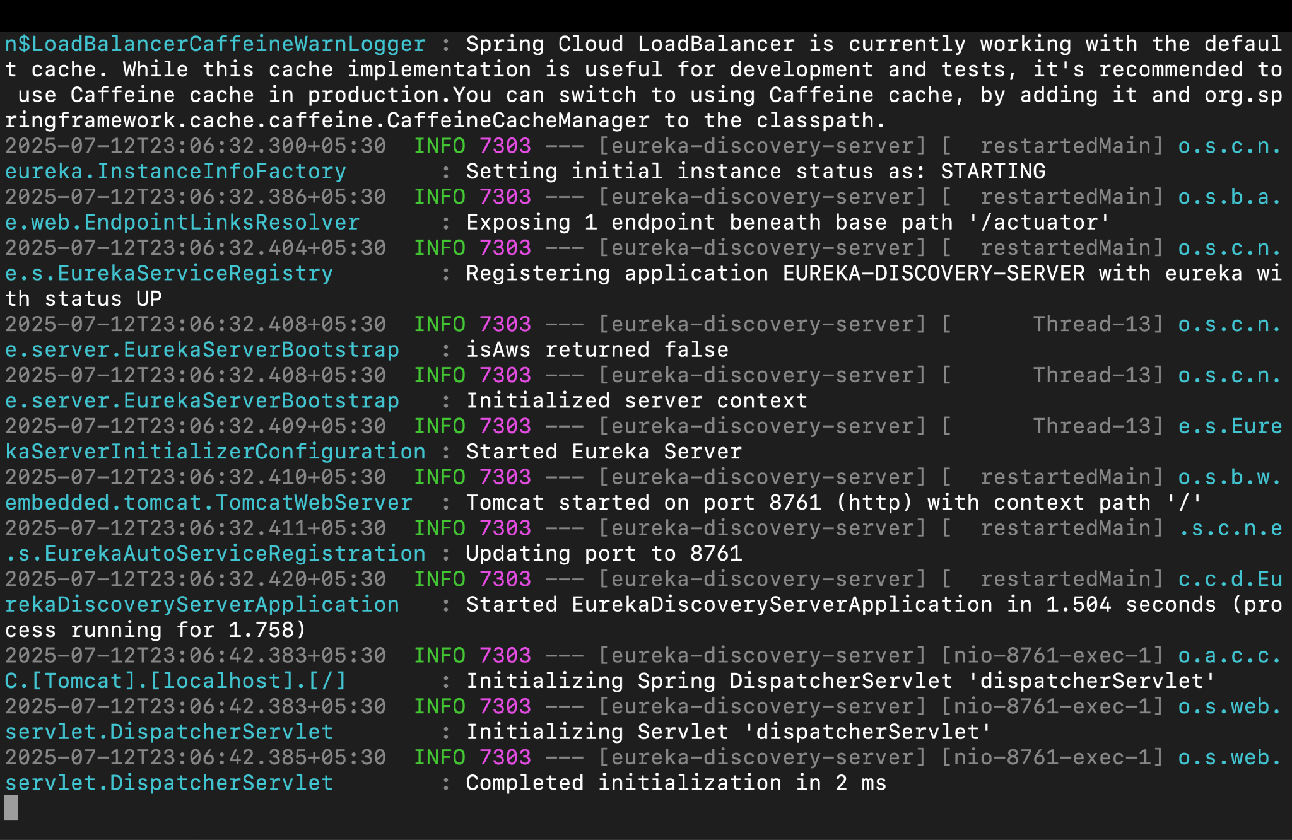

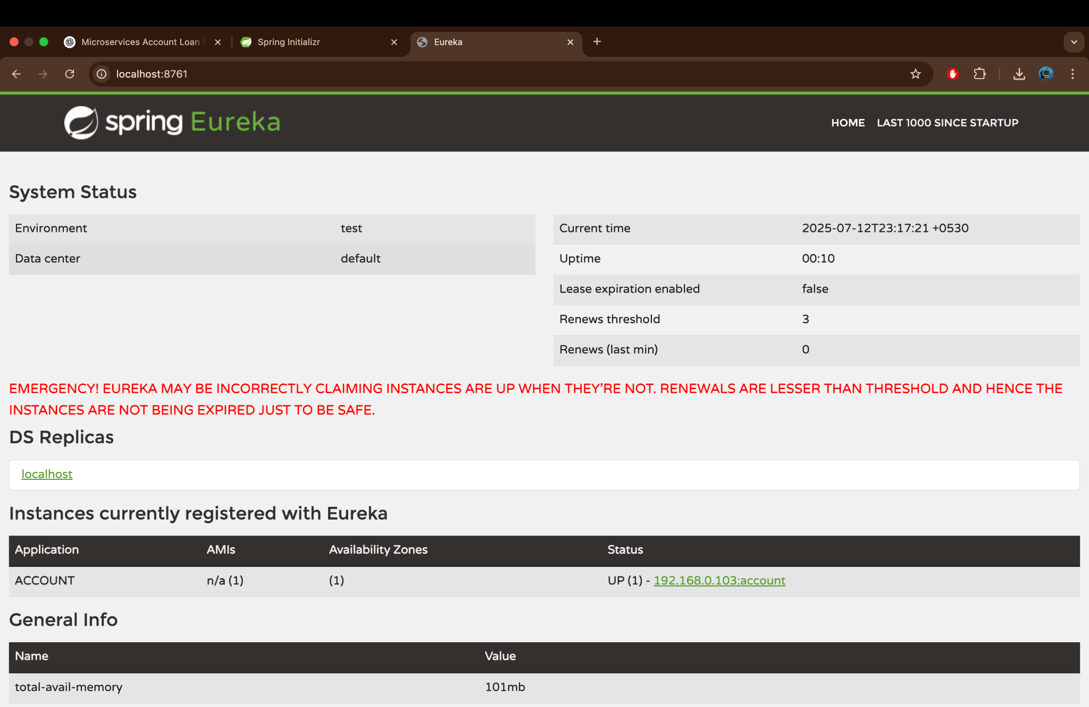

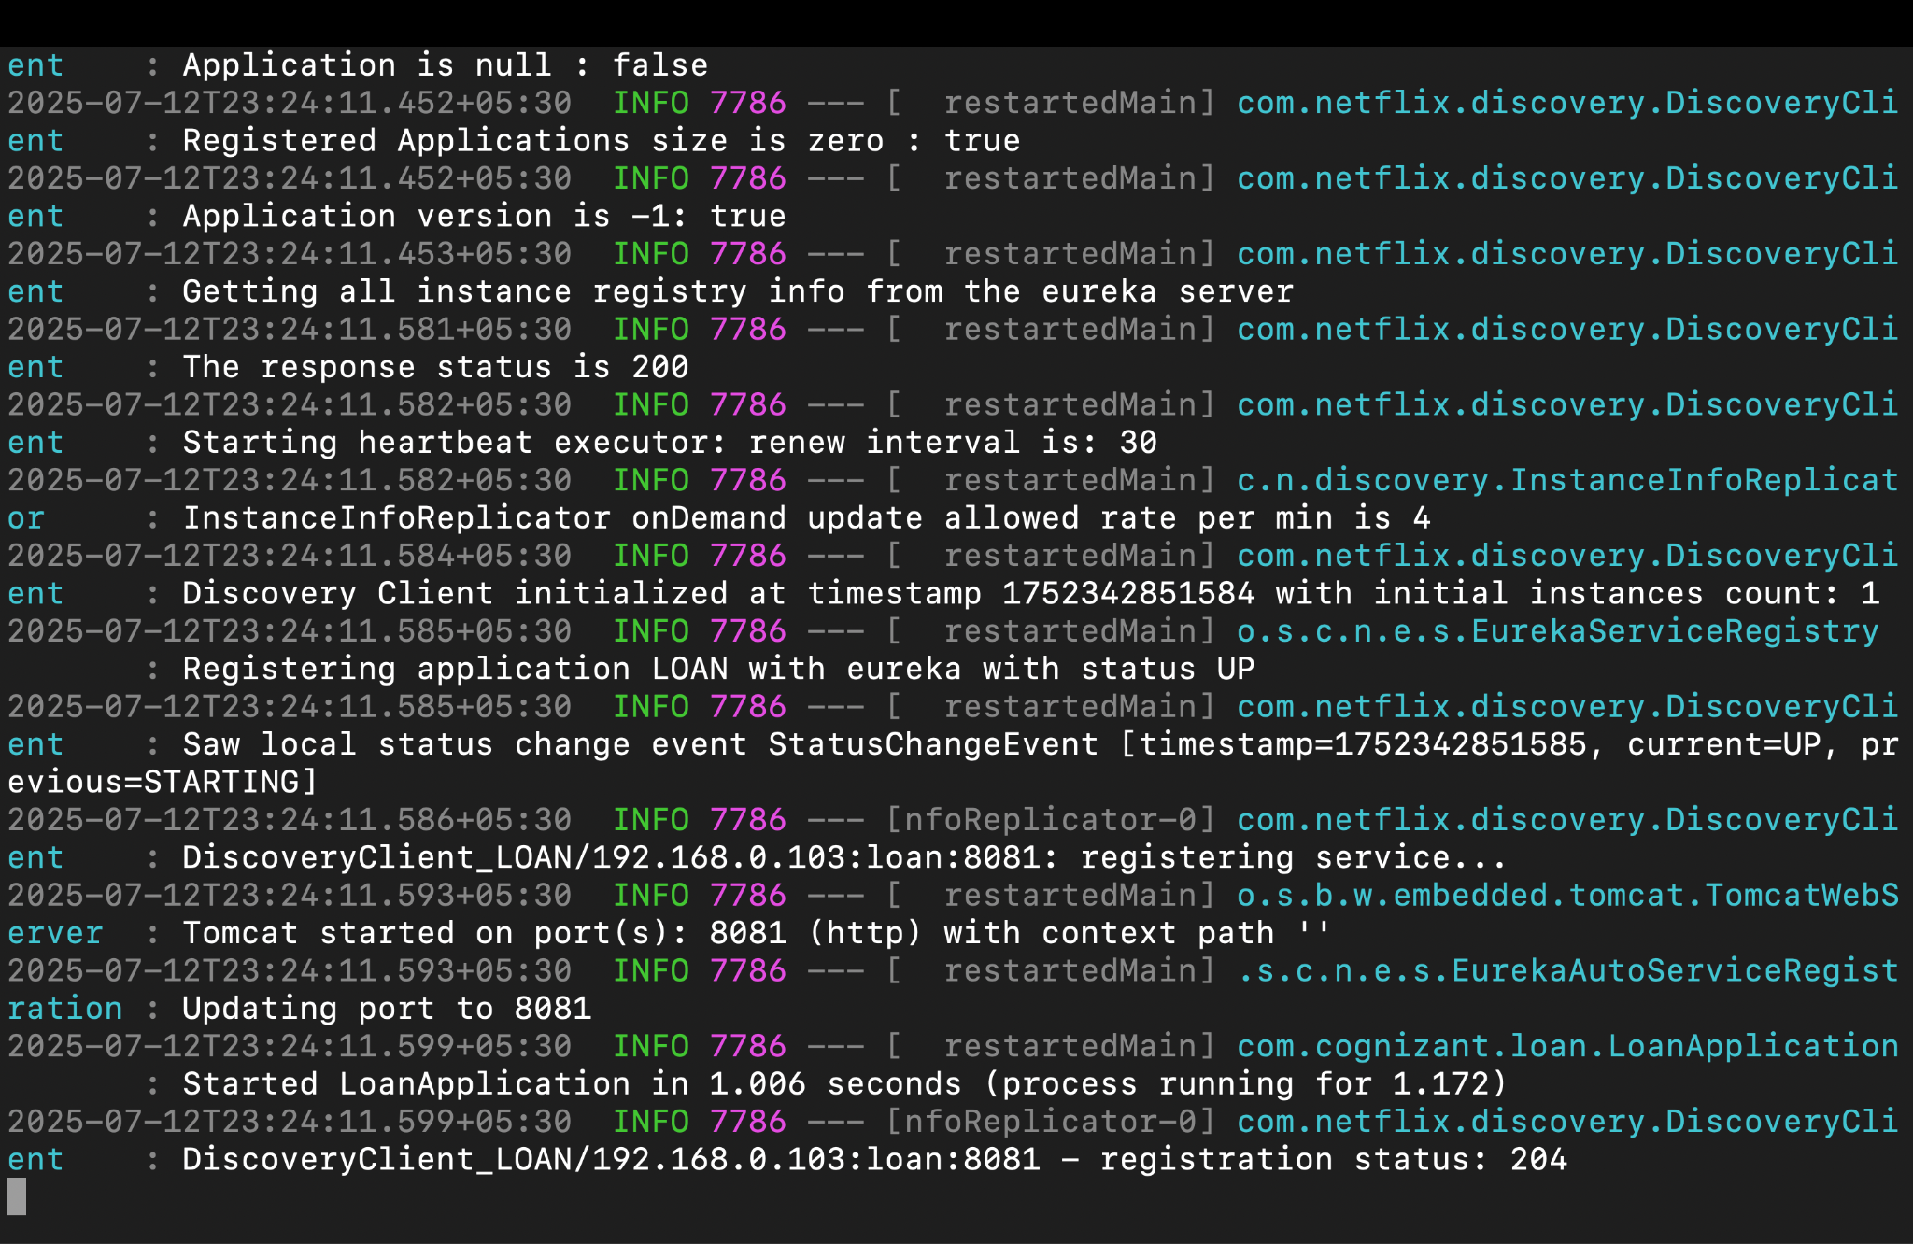
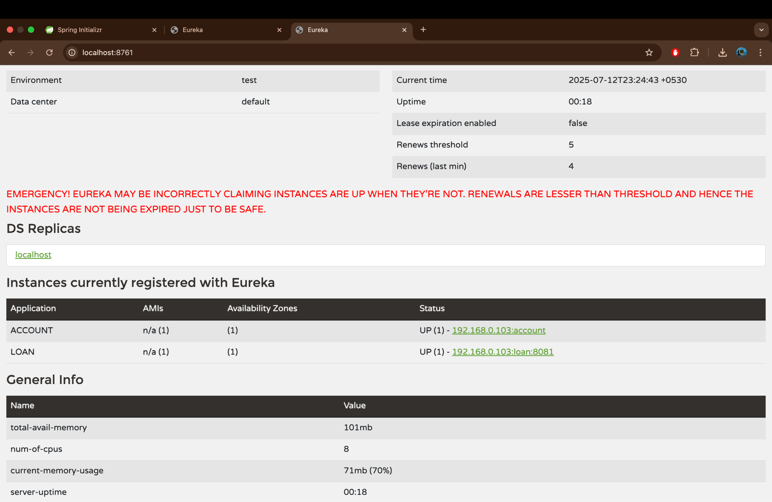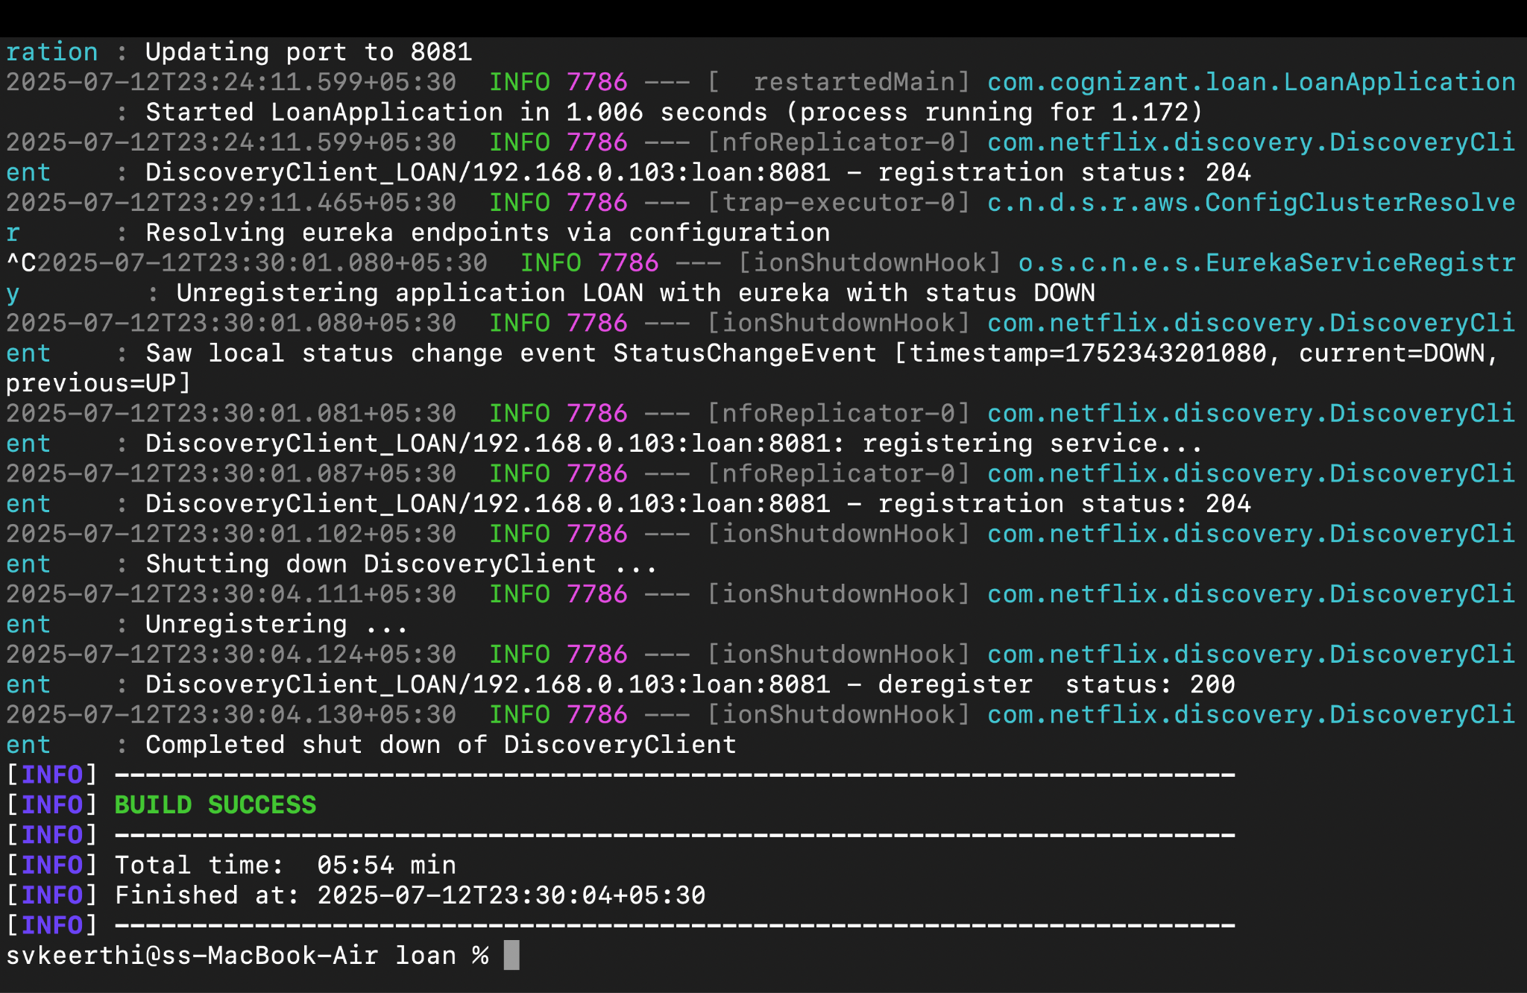

package com.cognizant.gateway;

import org.springframework.boot.SpringApplication;
import org.springframework.boot.autoconfigure.SpringBootApplication;
import org.springframework.cloud.client.discovery.EnableDiscoveryClient;

@SpringBootApplication
@EnableDiscoveryClient
public class ApiGatewayApplication {
public static void main(String[] args) {
SpringApplication.run(ApiGatewayApplication.class, args);
}
}
server.port=9090
spring.application.name=API-GATEWAY
eureka.client.service-url.defaultZone=http://localhost:8761/eureka

# ACCOUNT Route
spring.cloud.gateway.routes[0].id=ACCOUNT
spring.cloud.gateway.routes[0].uri=lb://ACCOUNT
spring.cloud.gateway.routes[0].predicates[0]=Path=/account/**

# LOAN Route
spring.cloud.gateway.routes[1].id=LOAN
spring.cloud.gateway.routes[1].uri=lb://LOAN
spring.cloud.gateway.routes[1].predicates[0]=Path=/loan/**

Output:

